**Week 1 Task**

**Completed the following tasks**

**Task1:** Created 4 separate tables with following columns using the **given CSV file**

**Inventory Table**

1. Product type

2. SKU

3. Availability

4. Number of products sold

5. Customer demographics

6. Stock levels

7. Lead times

8. Order quantities

9. Lead time

10. Revenue generated

**Manufacturing table**

1. Product type

2. SKU

3. Production volumes

4. Manutacturing lead time

5. Manufacturing costs

6. Inspection results

7. ⁠ defect rates

**Supplier Table**

1. Supplier name

2. Location

3. Lead time

4. transportation modes

5. Routes

**Supply chain table**

1. Product type

2. SKU

3. Price

4. Availability

5. Number of products sold

6. Revenue generated

7. Customer demographics

8. Stock levels

9. Lead times

10. Order quantities

11. Shipping times

12. Shipping carriers

13. Shipping costs

14. Supplier name

15. Location

16. Lead time

17. Transportation modes

18. Routes

**Task 2: Added the Screenshot of the 4 tables in the PowerBI desktop**

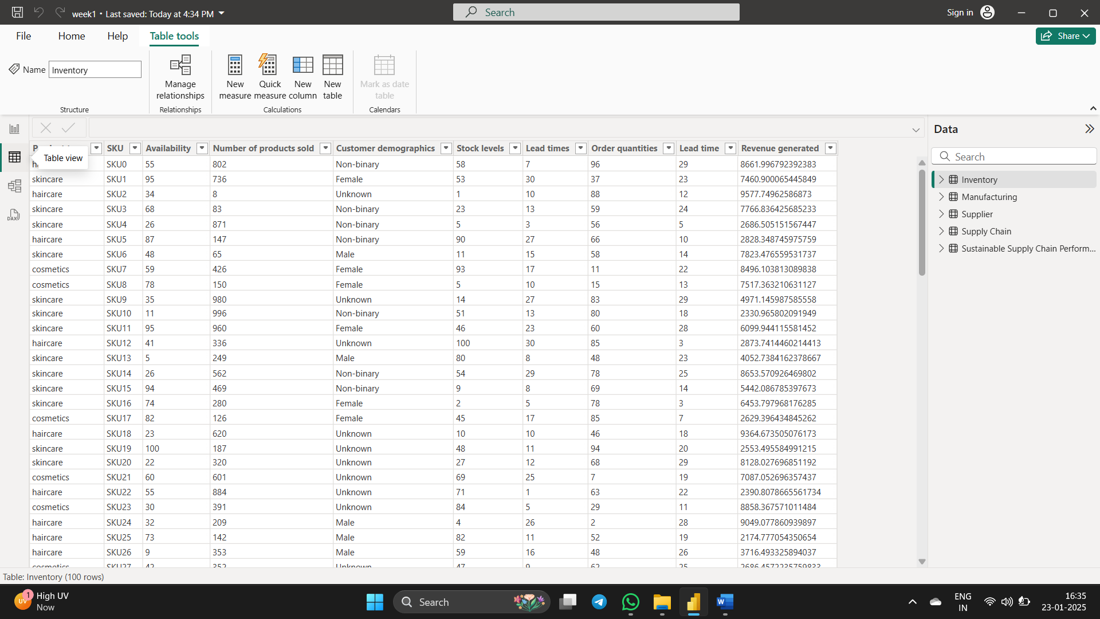

**Task 3 : Saved the PowerBI file as Week1.pbix and upload in the Github as repository**